Network Oversubscription Considerations

Typical campus networks are engineered with oversubscription. It is not generally practical to provide line rate for every port upstream from the access-to-distribution switch, the distribution-to-core switch, or even for core-to-core links. Even though bandwidth capacity has increased to 1 Gbps, multiples of 1 Gbps, and even 10 Gbps, it is still impractical to provide enough bandwidth to run an entire access layer switch full of ports at line rate at the same time.

The rule-of-thumb recommendation for oversubscription is 20:1 for access ports on the access-to-distribution uplink. The recommendation is 4:1 for the distribution-to-core links. In the data center, you may need a 1:1 ratio.

Using these oversubscription ratios, congestion on the uplinks occurs by design.
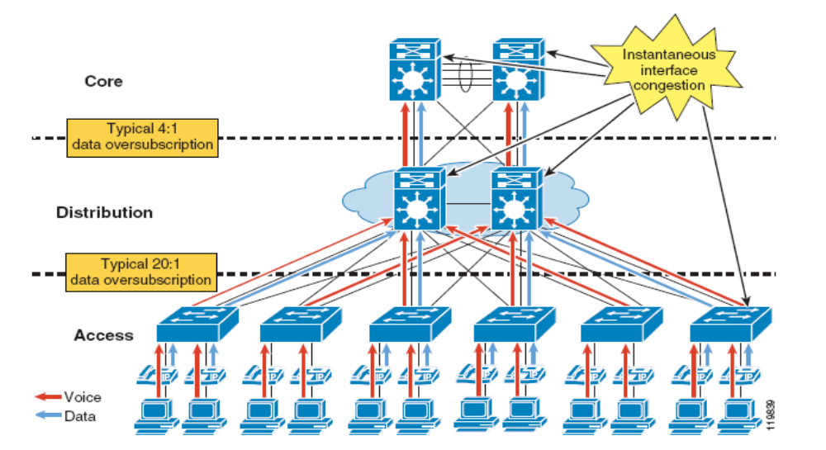
Figure 1 Typical Oversubscription
When congestion does occur, QoS is required to protect important traffic such as mission-critical data applications, voice, and video. Additionally, you can use QoS to reduce the priority of unwanted traffic. For example, an Internet worm infection, such as Slammer, can cause congestion on many links in the network, and QoS can minimize the effect of this event.

Congestion on a Cisco Catalyst switch interface is not typically caused by oversubscription or an anomaly such as an Internet worm. However, you must design for the unexpected to ensure that mission-critical applications including voice and video survive such situations.
Transmit queue

The type of congestion that is more prevalent in a campus network is called transmit queue (TX-queue) starvation. During a transition from LAN to WAN, a router has to make the rate transition from 10/100 Ethernet to WAN speeds. When this happens, the router must queue the packets and apply QoS to ensure that important traffic is transmitted first.
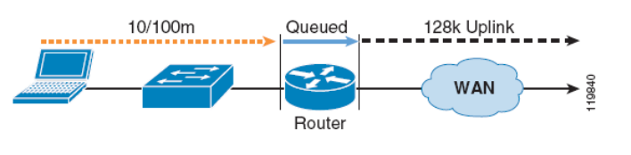
Figure 2 Tx-Queue

Starvation occurs when incoming packets are serialized faster than outgoing packets. Packets are queued as they wait to serialize out onto the slower link.

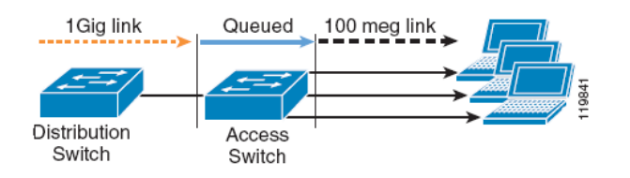
Figure 3 LAN TX Rates
In the campus, as we transition from 10 Gbps or 1 Gbps to 10/100 Gbps to the desktop, packets must be queued as they wait to serialize out the 10 or 100 Mbps link. The difference between a WAN router and a campus switch is the number of interfaces and the amount of memory associated with each. In the campus, the amount of Tx-queue space is much smaller than the amount of memory available in a WAN router. Because of this small amount of memory, the potential for dropped traffic because of Tx-queue starvation is relatively high.

Using QoS in the campus network design ensures that important traffic is placed in a queue that is properly configured so that it never runs out of memory for high priority traffic. Under normal circumstances, the network should provide an adequate level of service for all network traffic, including lower priority best-effort traffic.

During periods of congestion, scavenger-class traffic is the first to experience Tx-queue starvation and packet loss because the bandwidth is reserved for higher priority traffic.

QoS Recommendations
- As illustrated in the example above, existing QoS markings for Distribution switches overlap. Clean-up is required to insure each type of marking (ef, af41, cs3, etc) appear in only one queue
- QoS markings are primarily a mechanism to avoid congestion (amount of traffic in a given amount of bandwidth) and jitter (the reassembling of packets upon their arrival). In high bandwidth environments, the benefits of QoS markings may be minimal for congestion, but there is always the potential for jitter. By applying traffic shaping, jitter can be managed if it is found to be an issue here. Jitter must be consistently monitored to identify it’s presence, and properly managed, moving forward.

Because the 6500 is an overgrown switch on which routing has been grafted, so you should be careful about the hardware limitations of the forwarding cards. If these were removed entirely, the hardware queue will be FIFO, which may be acceptable if your layer-3 queuing is implemented properly.
- Apply L3 QoS to low bandwidth sites, to avoid congestion.
- Layer 3 QoS should be marked only at the Distribution layer and the WAN edge only.

